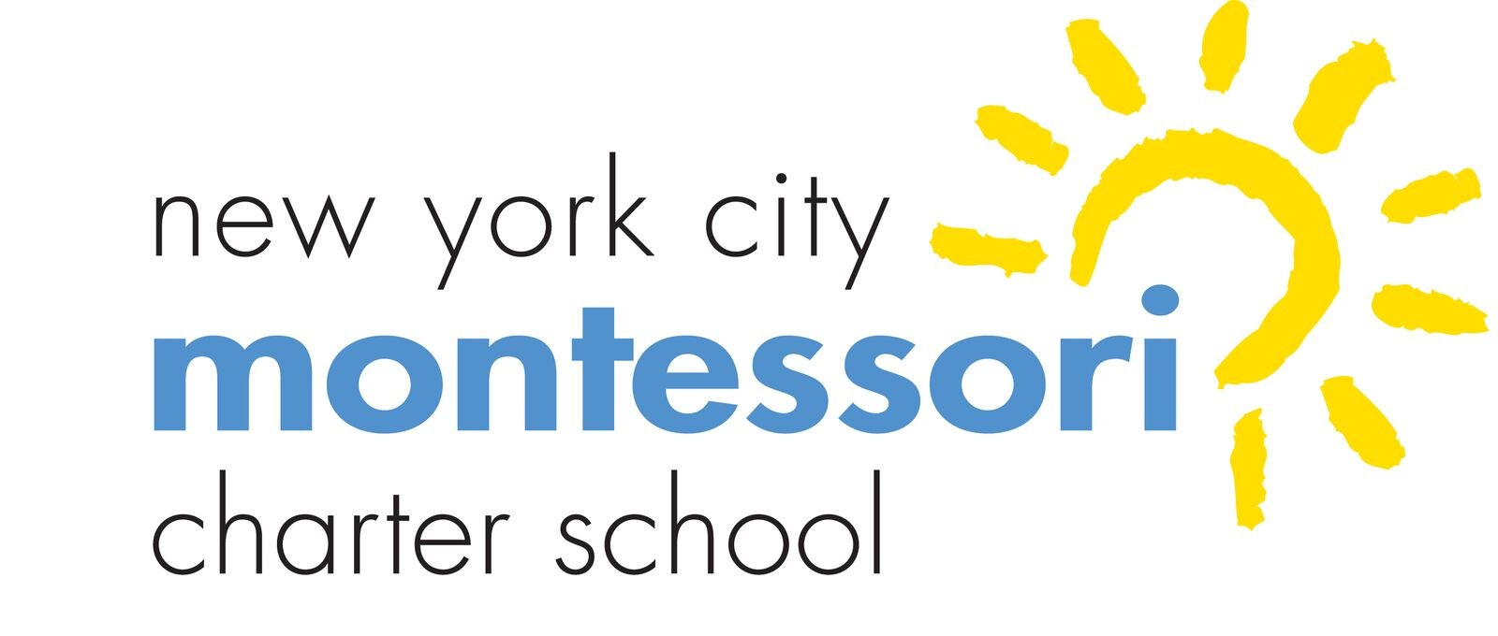
New York City Montessori Charter School (NYCMCS)
Board of Trustees Monthly Meeting

Via Video Conference
June 15, 2022 at 9:30 a.m.

AGENDA

- Call to Order/Roll Call (1 minute)

- Public Comments (2 minutes per person)

- Approval of Minutes—May 2022 (5 minutes)

- Dashboard Review and Principal’s Report (12 minutes)

- Committee or Task Force Reports (20 minutes)
  - Building and Grounds Committee Report – negotiations with landlord
  - Education Committee Report
  - Finance Committee Report – budget
  - Family Association Report – family engagement
  - Special Committee
- Annual Reports from Committees – due to Board Chair by July 1
- Consent Agenda
  - Election of Slate of Officers and Membership Terms – due to Board Chair by July 1
  - Appointment of Committee Chairs & Members to Committees– due to Board Chair by July 1
  - Approval of School Manuals (Board of Trustee Bylaws and Family Handbook)
  - Approval to forward manuals for review (finance manual to CSBM and employee handbook to Synuity)
  - Set Board and Committee schedules for upcoming school year by July 1
  - Individual Board Members Self-Evaluations– due to Board Chair by July 1
  - Board Evaluation – we completed that in March.
  - Individual Board Members Financial Disclosure Forms– due to Board Chair by July 1
  - Approval of Accountability Plan, Board Goals, Principal Goals for upcoming school year
  - Approval of CSBM contract for upcoming school year (under separate cover)

- Charter Renewal
- Board Enlargement

- EXECUTIVE SESSION - Board’s review and decision re Principal’s salary and request for advance

- Upcoming dates:
  - June 23 – 5th grade graduation
  - June 29– last day of classes
  - July 20 9:30 a.m. – Combined July and August Board meeting
  - August 29 – first day of classes

- Adjournment

