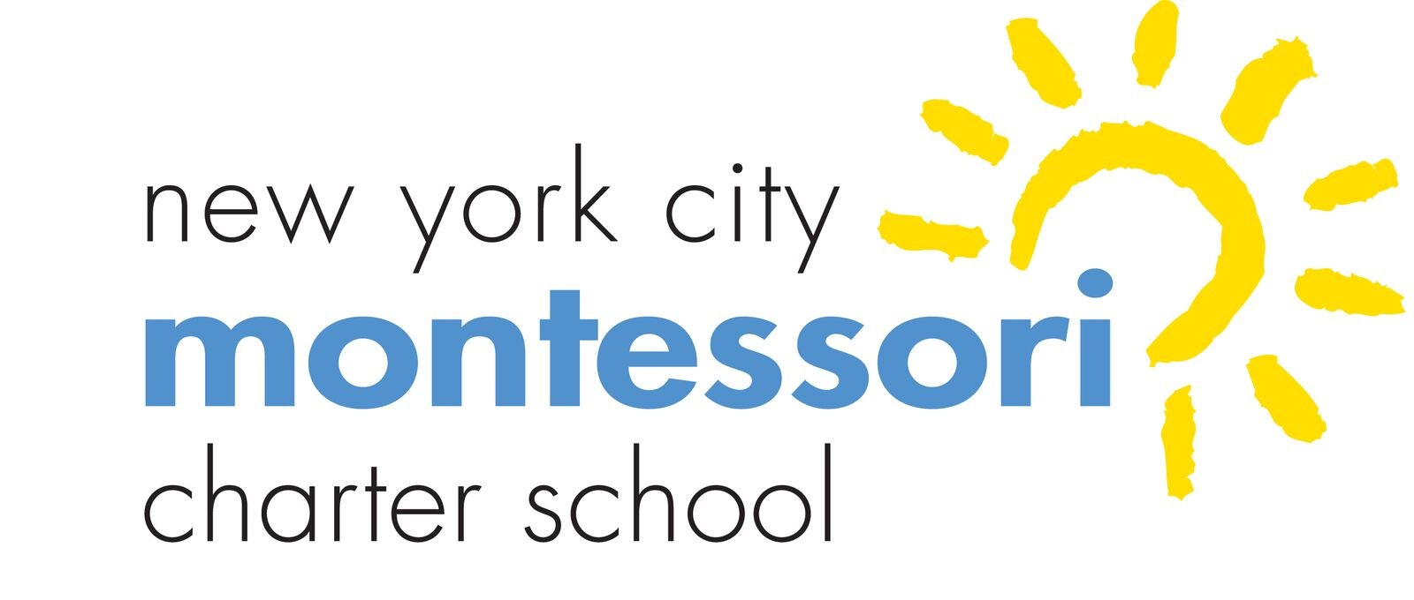
New York City Montessori Charter School (NYCMCS)
Board of Trustees Monthly Meeting

Via Video Conference
April 27, 2022 at 9:30 a.m.

AGENDA

- Call to Order/Roll Call (1 minute)
- Public Comments (2 minutes per person)
- Approval of Minutes—(5 minutes)
  - March 2022
- Principal’s Evaluation
- Dashboard Review and Principal’s Report (12 minutes)
- Committee or Task Force Reports (20 minutes)
  - Building and Grounds Committee
  - Education Committee Report
  - Finance Committee Report
  - Family Association Report
  - Special Committee Report
- Adjournment

