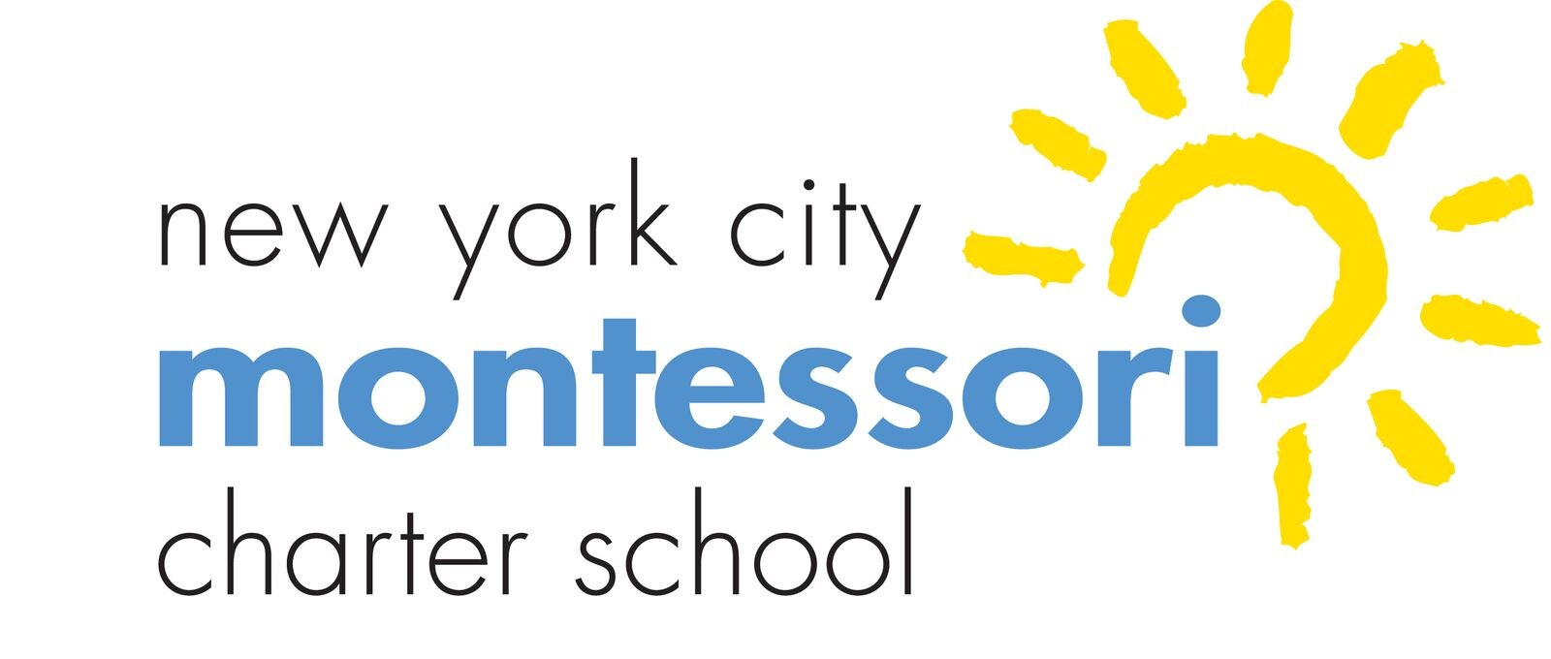
New York City Montessori Charter School (NYCMCS)
Board of Trustees Monthly Meeting

Via Video Conference
January 19, 2021 at 9:30 a.m.

AGENDA

- Call to Order/Roll Call (1 minute)
- Public Comments (2 minutes per person)
- Approval of Minutes—(5 minutes)
  - December 2021
- Dashboard Review and Principal’s Report (12 minutes)
- Revision of NYCMCS’ 2020-2021 goals
- Board governance assessment for this school year
- Processes assessment (to be spearheaded by Anthony Jordan)
- Committee or Task Force Reports (20 minutes)
  - Building and Grounds Committee
  - Education Committee Report
  - Finance Committee Report
  - Family Association Report
- Adjournment

